Knauf · Tempus Resource

Project Manager Guide
A focused, hands-on reference for Project Managers and Service Managers who plan their projects and services in Tempus Resource. Every chapter is written for day-to-day use: open it, find the screenshot, follow the steps.
Audience: PM/SM Planners at Knauf · Environment: `knaufdev.tempus-resource.com` · Phase 1 Scope
---
Contents at a glance
1. Getting started — sign-in and homescreen
2. Project Management Grid — find, search and open your projects
3. Creating a new project — Regular Project intake
4. Project Attributes — master data you maintain
5. Allocations — planning mandays for roles and resources
6. Financials — adding non-labor costs
7. Save, Checkout & Release — how data is committed to the central plan
8. Reports — opening and reading the reports built for you
9. Quick reference — icons, FAQs, troubleshooting
---
Document version: 1.0 · Built from the Knauf sandbox using the PM/SM (Dummy) login. Screenshots reflect the UI that PM/SMs actually see — the Resource Manager (RM) interface is intentionally not covered in this guide.

Contents
The table of contents below is generated live by Microsoft Word — right-click inside it and choose Update Field to refresh it after the document has been changed. It mirrors the heading structure of every chapter and supports Ctrl + Click to jump directly to a section.
Right-click here and choose 'Update Field' (or press F9) to build the table of contents.

1. Getting started

Signing in
Open `knaufdev.tempus-resource.com` in your browser. Knauf uses single sign-on (SSO), so you will be redirected to the corporate identity provider — sign in with your Knauf account exactly as you would for any other internal tool. If you accidentally land on the local Tempus login screen, just click Continue with SSO and you will be forwarded correctly. As soon as the authentication completes, Tempus Resource opens on your personal homescreen.

The homescreen
The homescreen is your starting point every time you launch Tempus. As a Project or Service Manager you see exactly two tiles:
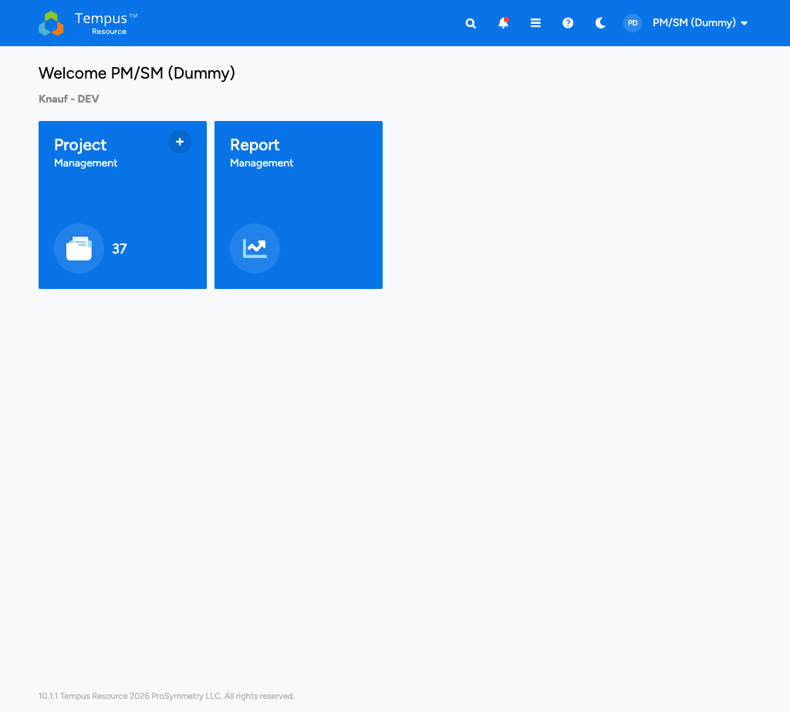
PM/SM Homescreen showing two tiles: Project Management and Report Management
The Project Management tile takes you to the grid that lists all projects and services you are allowed to plan; the number in the bottom left of the tile (here: 37) shows how many records are currently in your scope. The Report Management tile opens the report library where you can run the standard PMO and finance reports built for Knauf. Other roles — for example Resource Managers — see additional tiles such as Bulk Project Allocation Flatgrid here, but PMs and SMs work exclusively from these two entry points.

The top bar
Independent of the page you are on, the dark blue bar at the very top of the screen carries the global controls. From left to right, the right-hand side of the top bar exposes a global search to jump to any project by name, a bell that lights up red when you have unread system notifications (resource requests, approvals, comments), a hamburger menu with module shortcuts, and a question mark that opens the ProSymmetry Help Center in a new tab. The avatar pill on the far right (here showing `PM/SM (Dummy)`) drops down to your Profile, Subscriptions and Logout options. These controls do not change between modules, so once you know them you can navigate the whole product without losing your bearings.

What to do on day one
Before you open a project for the first time, spend two minutes on the homescreen and confirm three things: that your tile count matches the number of projects you actually own, that the user badge shows your own name (not a colleague's), and that the bell shows no unread alerts — otherwise you may be working on stale information. Once that is in place, click the Project Management tile and continue with chapter 2.

2. The Project Management Grid
The Project Management Grid is where 90 % of your time inside Tempus is spent. Every project and service you have access to appears here as a single row; everything you do — opening attributes, planning resources, adding costs, exporting data — starts from this list.
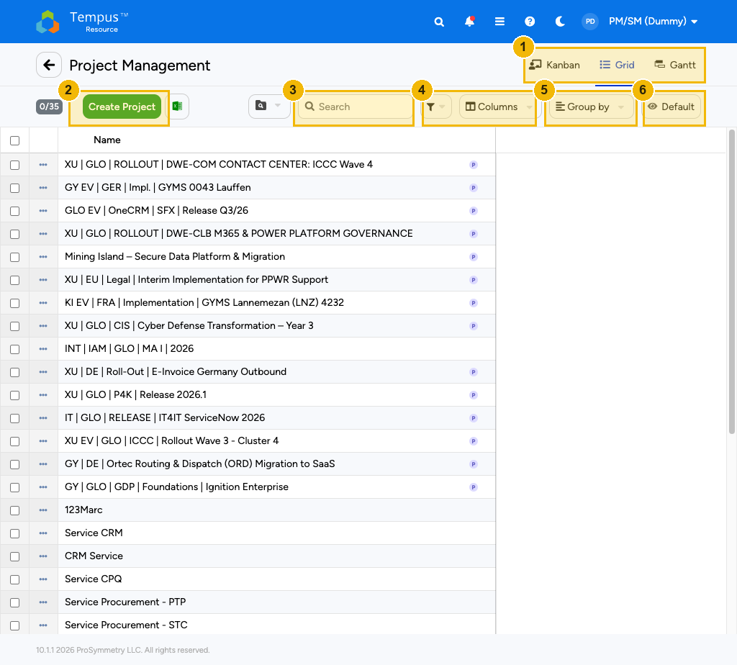
Project Management Grid with toolbar callouts
The numbered highlights in the screenshot above correspond to the six controls you will use every day. Box (1) are the three view tabs Kanban, Grid and Gantt — they switch between a card-based view, the spreadsheet-style grid (default, what you see here) and a timeline. Box (2) is the Create Project button — used in chapter 3 to launch a new regular project. Box (3) is the free-text Search which filters the list in real time as you type. Box (4) combines the Filter funnel and the Columns chooser which decides what data points are visible as columns. Box (5) is the Group by dropdown that buckets the list (for example by Portfolio or by Division). Finally, box (6) is the Default view selector — the gateway to the View Manager that we cover further down.

Toolbar at a glance
The same toolbar zoomed in:
Toolbar strip detail
Element | Purpose
`0/35` selection counter | Number of currently selected rows vs. total. Stays at `0/` until you tick a row.
Create Project | Opens the Regular Project intake form (chapter 3). Available to PM/SMs only.
Excel icon | One-click export of the visible grid to `.xlsx`. Respects active filters and columns.
View dropdown (folder icon) | Switches between saved Views — your personal layouts and the public Knauf views.
Search | Free-text filter that matches the project name.
Filter | Multi-condition filter (for example Division = Engineering AND Above Red Line = Yes).
Columns | Toggle which attributes show up as columns.
Group by | Adds an outer grouping level (collapsible).
Default | The current view, click to open the View Manager (see below).

Searching and filtering
For ad-hoc lookups, the easiest path is the Search box: type any fragment of the project name and the grid narrows down instantly. For recurring lookups — for example all my projects above the red line in Engineering — use Filter to build the condition once and save it as part of a view. Filters are AND-combined; remove a single condition by clicking the small `×` next to the chip below the toolbar.

Tabs: Kanban, Grid, Gantt
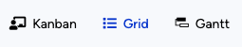
Tabs Kanban / Grid / Gantt
The Grid tab is the default and the most useful working surface — you can see many attributes side by side and edit them inline. The Kanban tab presents the same projects as cards, grouped by Portfolio Status by default, which is helpful when triaging the portfolio. The Gantt tab plots planned start and end dates on a horizontal timeline; it is read-only here and meant for sharing visual schedules with stakeholders.

Working with Views
A View is a saved combination of columns, filters, grouping, sort order and grain. Tempus comes with one personal view — your Default — and any number of public views published by the PMO. Click the Default button on the right of the toolbar to open the View Manager:
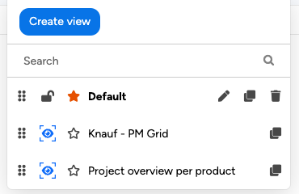
The View Manager: drag-handle and lock for private views, star, edit, clone and delete icons; public views (eye icon) live below your private ones.

The icons inside each row of the View Manager always mean the same thing: is the drag handle that lets you reorder the views by importance.  freezes a view so that filter or column changes do not persist — useful while you are demoing data. marks the view that opens automatically when you load this page; click on a different row to move the star. opens the view definition; duplicates a view, which is the recommended way to "edit" a public view (you cannot save changes back to a public view directly). removes a private view permanently — only visible on views you own. The  eye marker at the bottom of a row identifies a public view.
Tip. If you want to tweak one of the Knauf-standard views, always start by cloning it with ; then edit the copy and, optionally, give it your so it becomes your personal default.

3. Creating a project
Every initiative you want to plan in Tempus — be it a true project or a service — starts with the same intake form. As a PM/SM you only ever see one entry, Regular Project, in the Create Project dropdown; Knauf reserves any other intake template for the PMO core team.

Launching the intake form
From the Project Management Grid click the green Create Project button in the toolbar. A short pulldown appears with the single option Regular Project — pick it and the intake screen opens immediately on a blank record. The header strip looks like this:
Create Project header with project name field and Create button
The two essentials are the Project name field on the left (box (1)) and the green Create button (box (2)). Until you type a name and click Create, no row exists in the database, so you can safely close the page if you change your mind. The View selector in the top right corner is fixed to Attributes while you are creating a record — sections like Allocations or Financials only become available after the record has been saved.

Filling in the Intake Form
The intake form is split into two collapsible sections. The first, Intake Form, gathers everything the PMO needs to slot the project into the portfolio:
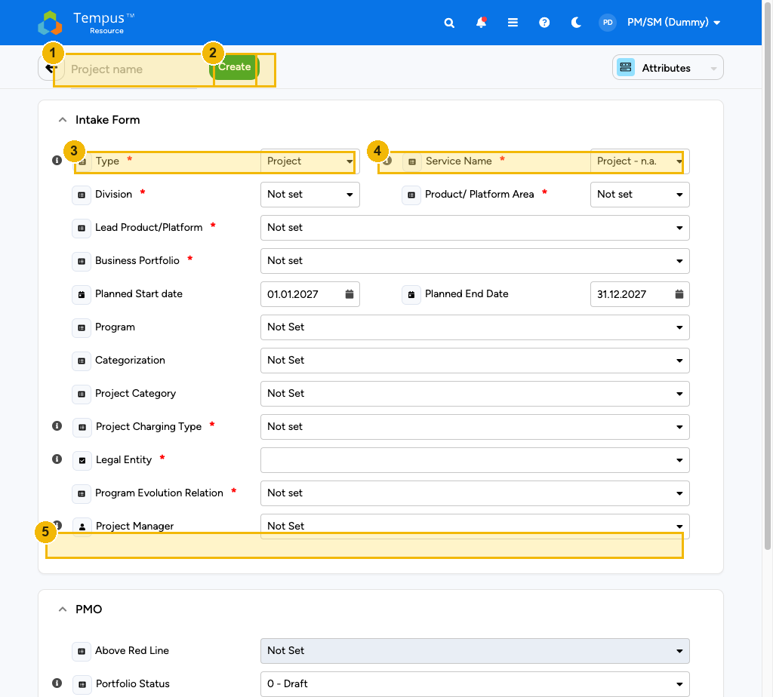
Intake Form section with all fields visible
The two top fields decide what kind of work you are recording: in box (3) choose the Type — `Project if this is a one-off initiative, Service if it represents recurring run effort. As soon as you pick Service`, the Service Name dropdown in box (4) becomes mandatory and must point to the corresponding service entry (typically a recurring activity such as CRM Run or Procurement — PTP). Below that you select the Division, the Product / Platform Area, the Lead Product/Platform and the Business Portfolio; all of these are picklists maintained by the PMO and they control where the project surfaces in the public reports.
The next block sets the timing — Planned Start date and Planned End Date — both pre-filled with sensible defaults that you should adjust to your actual plan. The trio Program, Categorization and Project Category lets you group the project under a program or campaign; leave them as Not Set if there is no program in scope.
The bottom half of the section concerns governance: Project Charging Type decides how time and costs are charged (CAPEX, OPEX, internal, …), Legal Entity ties the project to the booking unit, and Program Evolution Relation marks whether the project is a new investment or an existing activity. Box (5) highlights the Project Manager field — this points to you by default. Switch the value only if you are intaking a project on behalf of a colleague, because the Project Manager controls who can later check the project out for editing.
Note: Required fields are marked with a small red asterisk in the UI. Tempus refuses to create the project until every red-starred field is filled — but you can always save the intake with non-required fields left empty and complete them later from the Attributes view covered in chapter 4.

Filling in the PMO section
Scrolling further down you reach the PMO section. The fields here are owned by the PMO but you should still set the ones you know:
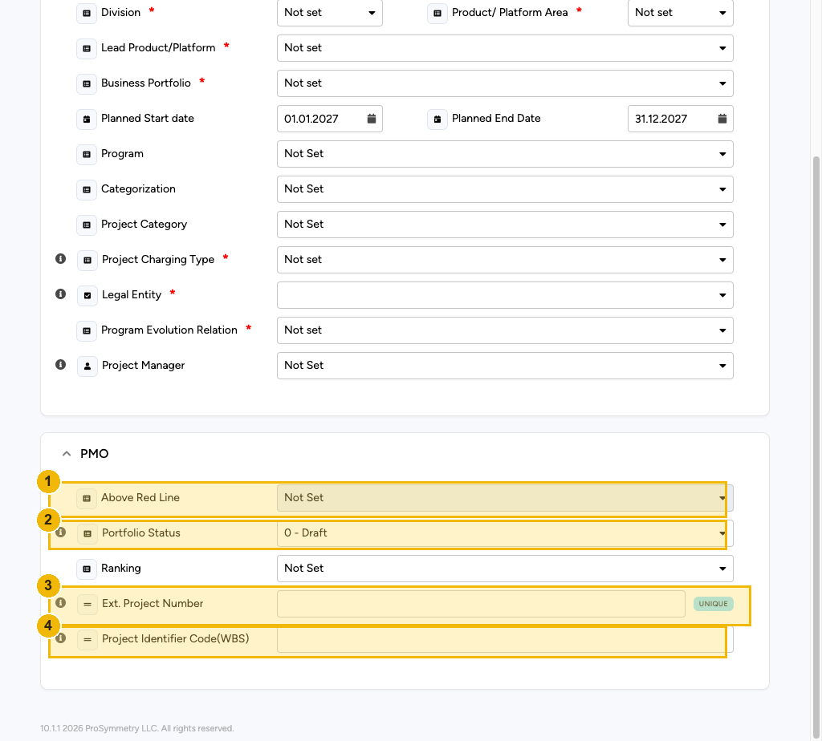
PMO section with Above Red Line, Portfolio Status, Ext. Project Number and WBS
Box (1) is Above Red Line — answer Yes if the project is part of the strategic above-the-line portfolio, No otherwise. Box (2) is Portfolio Status — leave it on `0 - Draft until the project has been formally approved; the PMO will move it forward through the lifecycle (1 - Pipeline, 2 - In Plan`, etc.). Box (3) is the Ext. Project Number that ties this record to your external bookkeeping. The little
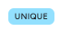
UNIQUE badge
badge that appears next to the field is Tempus telling you that the value has to be unique across the whole tenant — if you accidentally re-use a number, the save will be rejected. Finally, box (4) is the Project Identifier Code (WBS) which is the technical key under which time bookings and finance entries are reconciled.

Saving and exiting the intake
When all required fields are green-checked, click Create. Tempus takes a moment to provision the record and then jumps you straight into the Attributes view of the new project — that is the same screen we look at in detail in chapter 4. From there you can switch to Allocations or Financials using the view selector in the top-right corner of the screen.
If you need to leave the intake form before creating the project, use the back-arrow (←) in the top-left corner. Anything you typed but did not save will be discarded. To revisit an already created project, return to the Project Management Grid and click the project name.

4. Project Attributes (master data)
The Attributes view is the long-form record of a single project. It gathers everything the PMO needs to classify, govern and report on the project, and as a PM/SM you are the steward of the data here. The view opens automatically right after you finished the intake; you can also reach it any time by clicking a project name in the grid and choosing Attributes from the view selector in the top-right corner.
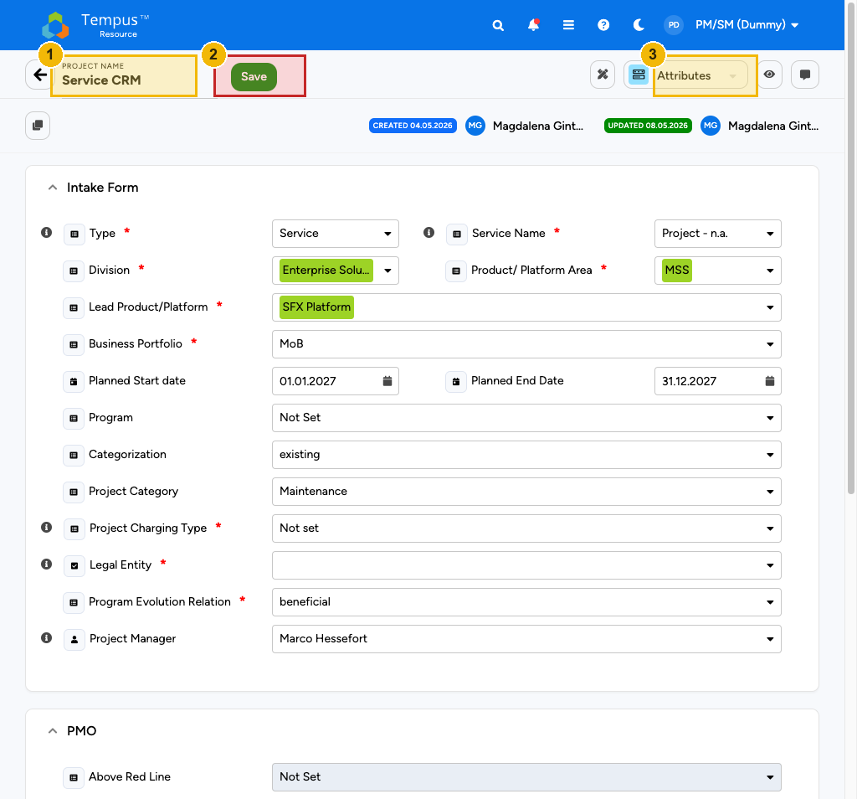
Service CRM in the Attributes view with Save button highlighted
The blue stripe at the top of the page tells you who you are looking at and what state the record is in. Box (1) is the editable Project name — change it at any time, it is the value that appears everywhere else in the product. Box (2) is the Save button. Tempus keeps a local draft of your edits, but they are only persisted to the central database once you press Save; if you leave the page without saving, your changes are lost. Box (3) is the view selector — drop it open to jump between Attributes, Allocations and Financials without going back to the grid.
To the right of those primary controls Tempus shows audit information (Created on 04.05.2026 by Magdalena Gint… / Updated on 08.05.2026 by …) so you can always tell when the project was last touched and by whom. The little icon under the project name is Clone Project: useful when you start a new project that has the same governance attributes as an existing one — clone, rename, adjust.

Reading the Attributes sections
The body of the page is the same Intake Form / PMO structure you already know from chapter 3, only filled with real values. Because PMs/SMs can edit every field on this page after the project has been created, treat the Attributes view as the master data sheet for the project: keep Type, Division, Product / Platform Area, Lead Product/Platform, Business Portfolio and the planning dates correct at all times — those five attributes drive every report and the Bulk Project Allocation views that the Resource Managers use to plan their teams.
The Project Manager field deserves a dedicated note. Re-assigning a project to a different PM/SM here is the only way that person will later be allowed to check the project out for editing in Allocations or Financials — see chapter 7 for the mechanics.

A practical edit loop
The typical edit loop on this page is short and worth memorising:
1. Open the project from the Project Management Grid.
2. Make changes to the fields you need to update.
3. Click Save .
4. Wait for the green confirmation toast in the lower-right corner.
5. Switch to the next view if needed via the view selector in box (3).
If a field is greyed out, you do not have the permission to change it — most often that means the field is owned by the PMO. Reach out via the standard PMO channel; do not work around it by editing a different field.

Services vs. projects
Services use the exact same Attributes view as projects — the only difference is the value of the Type field at the very top of the Intake Form: set it to `Service and pick the corresponding **Service Name** from the dropdown immediately to the right. After saving, the record will appear with the standard service prefix in the grid (for example Service CRM or Service Procurement - PTP`) and the Resource Managers will plan recurring effort against it from the BPA Flatgrid.

5. Allocations — planning mandays
The Allocations view is the heart of project planning. Here you record how much effort each role (and, once nominated, each named person) is expected to spend on the project, per month. The total of all role rows is what eventually shows up in the Resource Manager's Bulk Project Allocation Flatgrid; the demand you create here drives their staffing decisions.
You reach the view in two clicks: open the project from the grid, then choose Allocations from the view selector in the top-right corner of the project page.
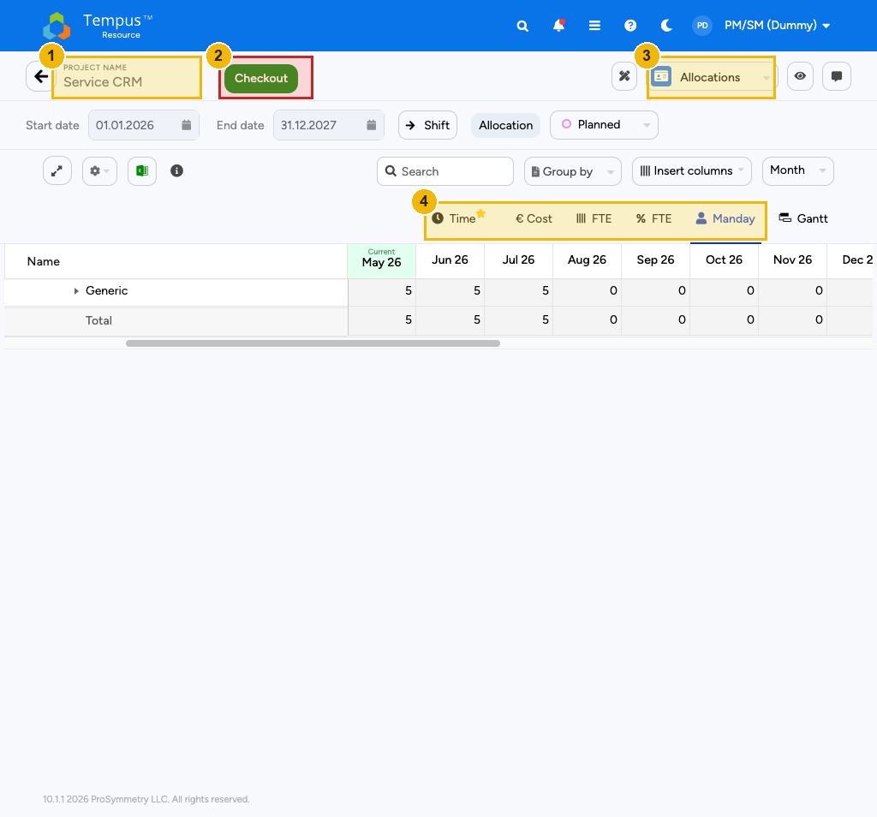
Allocations view in Mandays mode with the Checkout button highlighted
Three controls deserve attention right away. Box (1) is the project name strip, identical to the one on the Attributes view — you can change the name here as well, but you usually will not. Box (2) is the prominent red-bordered Save button. Because Allocations are a checkout-style surface (see chapter 7), the button is grey and labelled Checkout until you reserve the project for editing; once you do, it turns green and becomes the Save action. Box (3) is the view selector — your shortcut back to Attributes or forward to Financials. Box (4) is the most important new control: the Mandays ↔ Cost toggle that decides what unit the cells of the grid display.

Mandays vs. Cost
Allocations can be entered in two equivalent units:
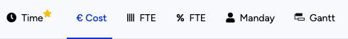
Mandays / Cost toggle detail
In Mandays mode (default, shown above) each cell is an integer number of resource-days per role per period. In Cost mode the same cell shows the corresponding euro amount, derived from the role's internal cost rate. The two units are different views of the same underlying data — Tempus converts on the fly. PM/SMs typically plan in Mandays because they think about effort, then flip to Cost once or twice during the planning cycle to sanity-check the resulting budget:
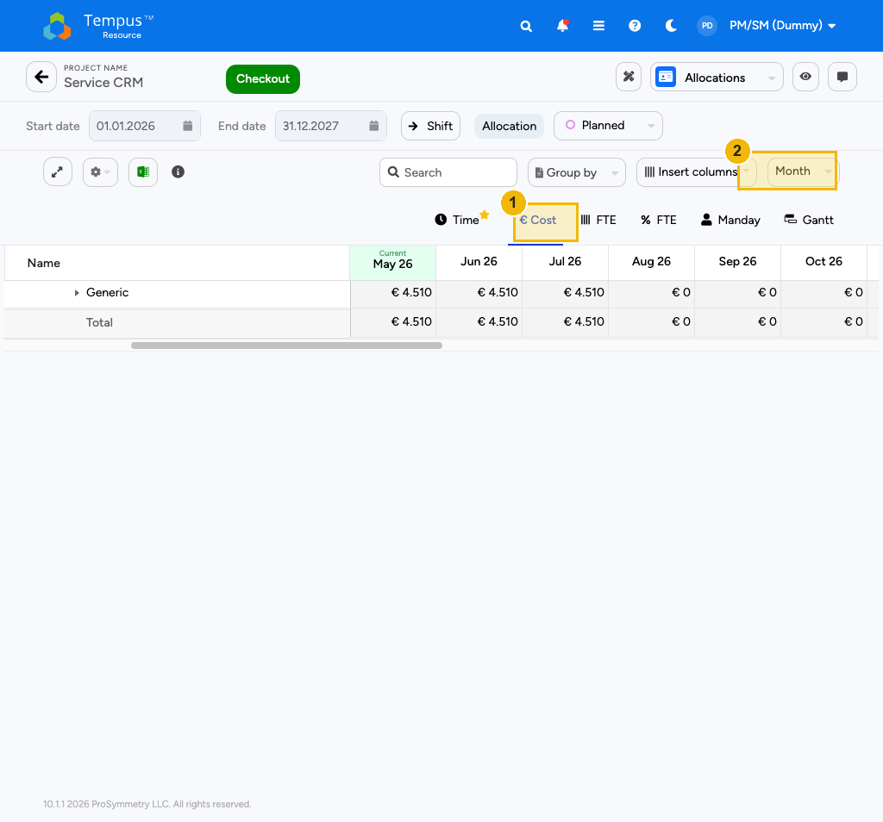
Allocations view in Cost mode
Box (1) is the toggle on Cost; box (2) sets the time grain of the columns — monthly is the standard, but you can switch to quarters or years when you want a high-level view.

How to enter allocations
The recommended workflow is:
1. From the Attributes view of an existing project, switch to Allocations.
2. Press the Checkout button. It immediately turns into Save and the grid becomes editable.
3. Click into the leftmost column of the row of the role you want to plan (or use Add Row above the grid if the role is not yet present). Pick the role from the dropdown.
4. Type the desired number of mandays into each month cell. Use `Tab to advance to the next column or Enter` to drop to the next row.
5. When done, click Save in the top-right corner. The toast in the lower-right corner confirms the persistence.
Tip: Bulk fill. Click the column header of any period and pick Fill down from the small column menu to copy the value of the selected cell into the whole column. This is the fastest way to seed a flat baseline that you then refine.

Requesting named resources
Up to this point you have allocated roles, not people. Once your plan is stable, you can nominate concrete colleagues by opening the Resource Request dialog on a role row (right-click → Request resource). The request lands in the inbox of the relevant Resource Manager, who decides whether to fulfil it from their team. The allocated mandays remain unchanged; only the row's Resource column moves from the generic role to a named person once the request is accepted.

Common pitfalls
A handful of issues come up repeatedly when PMs/SMs plan in Allocations:
- Editing without Checkout. If the Save button is grey, you have not checked the project out. Any keystrokes are visual only and will vanish on reload.
- Editing outside your planning horizon. Tempus does not stop you from editing past months, but those values do not contribute to future capacity calculations. Use Planned Start / Planned End on the Attributes view to keep the horizon honest.
- Forgetting to release. Saving persists the data, but the project remains checked out under your name until you press Release (chapter 7). Other people on the same project cannot edit while you hold the lock.

6. Financials — non-labor costs
The Financials view captures everything that is not paid in mandays: external service fees, software licences, hardware, travel, contingency. Labor costs derived from the allocations of chapter 5 flow into the same financial picture automatically — you do not re-enter them here.
Switch to Financials from any project page using the view selector in the top-right corner.
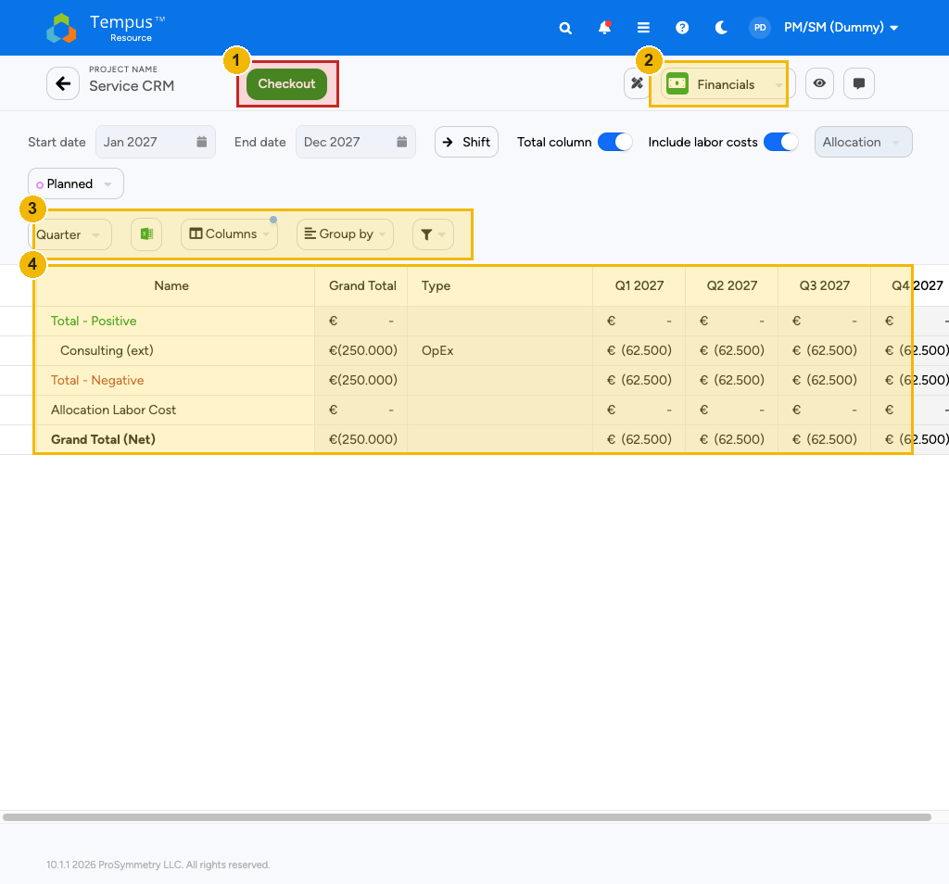
Financials view of a project
The structure mirrors the Allocations view. Box (1) is again the Checkout / Save button — Financials use the same checkout mechanic as Allocations (chapter 7). Box (2) is the toolbar above the grid containing the Add Row action that appends a new cost line. The grid itself shows one row per cost line, with the planning periods as columns.

How to enter cost lines
A cost line in Tempus is a tuple of:
Column | Meaning
Cost Category | The bucket the cost belongs to (e.g. External Services, Licences, Hardware, Travel, Other). Picklist owned by Finance.
Cost Type | Refinement of the category (e.g. T&M consulting under External Services). Filtered to entries that match the chosen category.
Supplier (optional) | A reference for documentation; does not affect the calculation.
Currency | Always EUR for Knauf. Locked.
Amount per period | The euro amount you expect to spend in that month/quarter/year.

To add a new cost line:
1. Press Checkout in the top-right corner (the button turns green and becomes Save).
2. Click Add Row in the toolbar of box (2). A blank row is appended at the bottom of the grid.
3. Pick the Cost Category and Cost Type in the first two columns of the new row.
4. Type the euro amount into each period column. Decimals are accepted, the locale is German (`1.234,56`).
5. Press Save when done. The Finance reports will pick up the value at the next scheduled refresh.
Note: Capex vs. Opex. Both flow through the same view; the capitalisation rule is derived from the Project Charging Type on the Attributes page. If a cost line is showing up under the wrong bucket in the finance report, fix the Charging Type first, then save — Tempus re-classifies the cost lines automatically.

Validating the budget
Once you have entered allocations and cost lines, switch the Allocations view to Cost mode (see chapter 5) and compare the labor totals to the non-labor totals in Financials. Together they give you the total committed project budget. The same number appears in the Total Cost column of the Project Management Grid — make sure it matches your business case before you ask the PMO to advance the project's Portfolio Status.

When the grid is empty
A project with no cost rows in Financials means the PM/SM did not plan any non-labor cost yet. That is a valid state for early- stage projects but should not last past the Pipeline phase: empty financials cause Knauf's portfolio dashboards to under-report the real investment. The PMO will follow up if a project sits in In Plan with empty financials for more than two weeks.

7. Save, Checkout & Release
Tempus uses two complementary mechanics to commit your work: Save for the surfaces that simply persist what you typed, and Checkout / Release for the surfaces where multiple users could collide. Knowing which surface uses which mechanic prevents the most common source of frustration — lost edits.

Save-only surfaces
The Attributes view (chapter 4) is a save-only surface. Multiple PMs/SMs almost never edit the same project's master data at the same moment, so Tempus does not enforce exclusivity. Edits stay in your browser as a draft; pressing Save in the top-right corner persists them and refreshes the audit information ("Updated on … by …"). If a colleague saves something between your open and your save, Tempus will warn you and let you reload before overwriting.

Checkout-style surfaces
The Allocations (chapter 5) and Financials (chapter 6) views do enforce exclusivity, because numbers in those views feed downstream calculations and conflicting edits would silently corrupt the plan. The cycle is:
Step | What you click | What happens
1 | Checkout | The grid becomes editable. A lock  is placed on the project under your name. No-one else can edit Allocations or Financials of this project until you release.
2 | (edit) | Your changes are persisted to your private draft on every cell change.
3 | Save | Your draft becomes the new central version. The lock stays with you.
4 | Release | The lock is removed and the project is editable by other authorised users again.

The Save and Release actions live in the same top-right strip of the project page. Always press Release before leaving the project — otherwise your colleagues will see a friendly "Locked by PM/SM (Dummy)" message and will be blocked. The PMO has an admin override but using it should remain the exception.
Tip: What if I forgot to release? Just go back to the project, press Release. You do not need to save again — the central data is already up to date from the last Save.

Edit modes per view
View | Edit mode | Save target | Lock holder | Notes
Attributes | Save-only | Central | none | Save persists immediately.
Allocations | Checkout  | Central, after Save | You, until Release | Mandays or Cost
Financials | Checkout  | Central, after Save | You, until Release | Non-labor cost lines

What "the central plan" means
Whenever this guide mentions "the central plan", it refers to the record of truth that all reports, the Resource Managers' BPA flatgrid and the Knauf finance dashboards read from. Your draft edits do not affect that record until you press Save. That is by design — it lets you try out scenarios without anyone else seeing half-baked numbers. The flipside is that you really must remember to Save and Release; otherwise your work neither shows up in the plan nor frees the project for the rest of the team.

8. Reports
The Report Management tile on the homescreen leads to the library of standard Knauf reports — portfolio dashboards, financial roll-ups, allocation overviews, and resource utilisation views built and curated by the PMO. As a PM/SM you only consume these reports; authoring is done by the PMO.
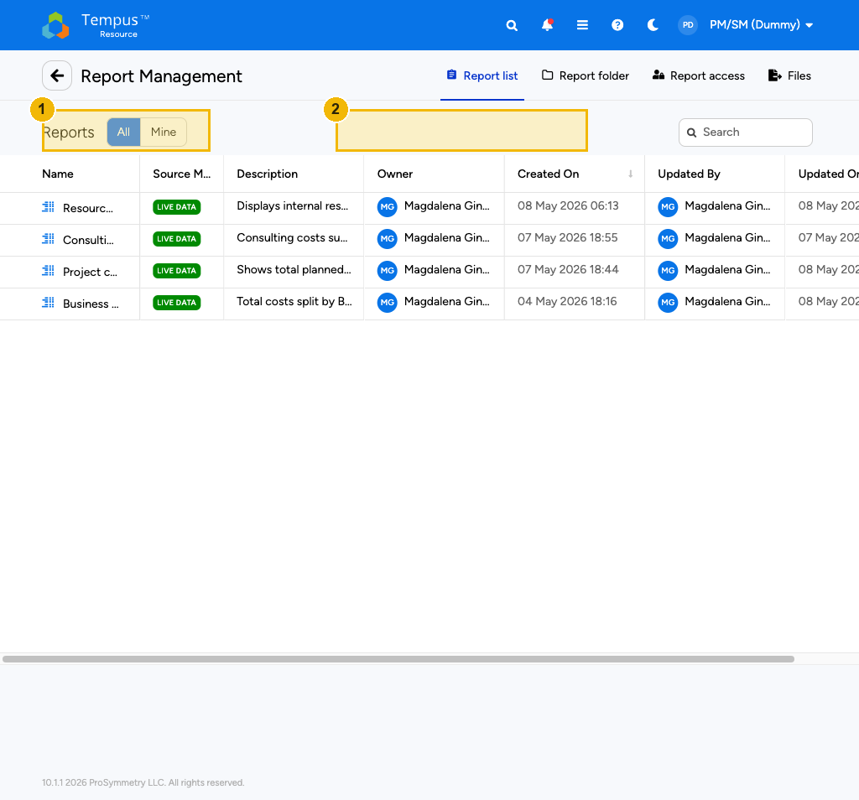
Report Management library
The page shows two helpful controls at the top of the list. Box (1) is the All / Mine toggle — flip it to Mine to see only reports that you have personally subscribed to (via the Subscriptions menu in your avatar dropdown). Box (2) is the Search box that filters the library by report name in real time.
To run a report, click its title. Most reports open in a new tab with a parameter prompt (typically Portfolio, Time frame, Above Red Line). Set the parameters and press Run. The result can be exported to Excel or PDF from the toolbar of the result page.
Tip: Subscribing. If you find yourself running the same report every Monday morning, open it, click Subscribe in the toolbar and pick the weekly cadence. Tempus will email you the rendered report on schedule.

---

9. Quick reference
This section is the cheat sheet you can keep open while you work. It collects the icons, shortcuts and remedies for the recurring questions that PMs/SMs ask in their first weeks with Tempus.

Icon cheat sheet
Inline | Where you see it | Meaning
 | Top bar | Global search
 | Top bar | System notifications (red dot = unread)
 | Top bar | Module shortcut menu
 | Top bar | ProSymmetry Help Center
 | View Manager | Reorder views
 | View Manager / project header | Locked view or checked-out project
 | View Manager | The current personal default view
 | View Manager | Click to make this view your default
 | View Manager | Edit view definition
 | View Manager / Attributes | Clone (view or project)
 | View Manager | Delete the private view
 | View Manager row footer | Public view marker

Mini FAQ
My Save button is grey on Allocations / Financials. You have not pressed Checkout yet. The button is only active for the user who holds the lock — see chapter 7.
Tempus says "Locked by …" on a project I want to edit. Another user is currently checked out on Allocations or Financials of that project. Ask them to Release; in an emergency the PMO can force- release via an admin tool.
I cannot see the BPA Flatgrid tile on my homescreen. Correct — that tile belongs to Resource Managers, not PM/SMs. You provide demand by entering allocations on each project (chapter 5); the RM consumes it from the BPA Flatgrid.
My project does not show up in the Portfolio Dashboard. Check that Above Red Line, Portfolio Status, Division and Business Portfolio are set on the Attributes page. Reports filter on those four attributes by default.
Edits disappear after a page reload. You forgot to Save. For Allocations / Financials, double-check that the Save button turned green (= you held the lock) before you typed.
The Mandays / Cost numbers do not match my business case. Open the project's Attributes and verify that the Project Charging Type and Legal Entity are correct — those drive the rate conversion that fills the Cost mode.
A field I need to change is greyed out. The field is owned by the PMO. Reach out to the PMO inbox; do not work around it through a different field.
I want to clone a Knauf-standard public view. Open the View Manager, click on the row of the public view, then edit the copy. You cannot save changes back into a public view directly.

Where to go from here
Once you are comfortable with the eight chapters above, the ProSymmetry Help Center ( in the top bar) is the right next stop for any topic that is not Knauf-specific — keyboard shortcuts, advanced filter syntax, history of cell edits. For Knauf process questions (when to advance Portfolio Status, what to write in External Project Number, how often to re-plan), the PMO team is the right contact.

